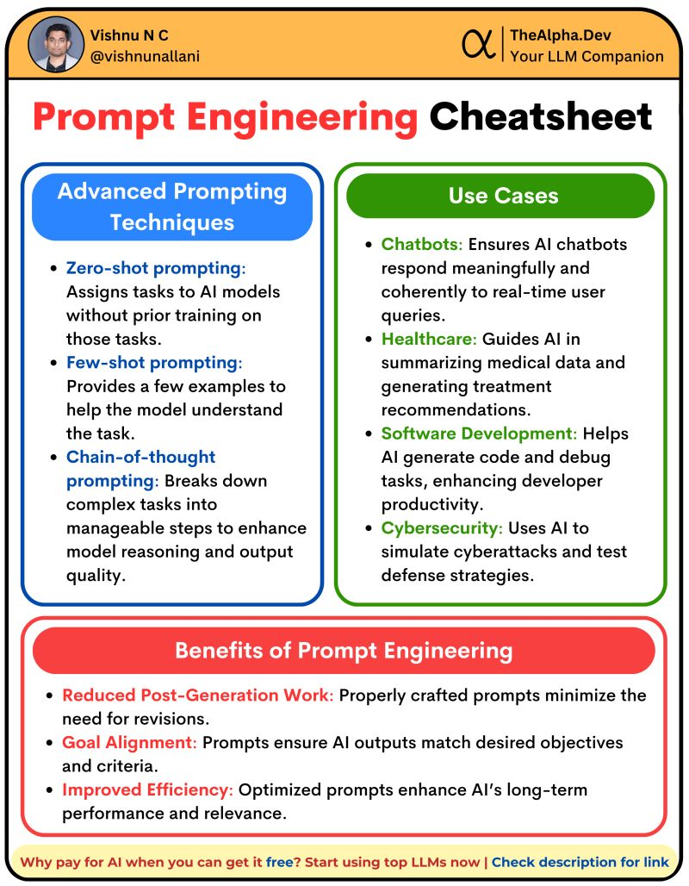

Access all popular LLMs from a single platform: <https://www.thealpha.dev/>